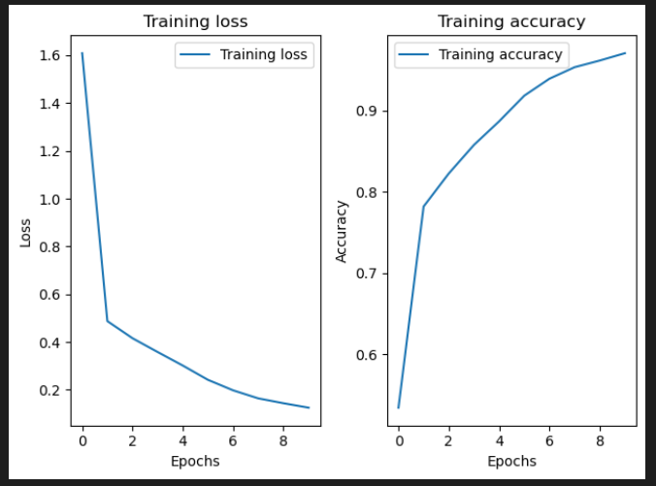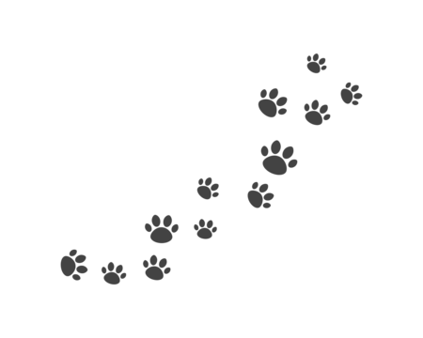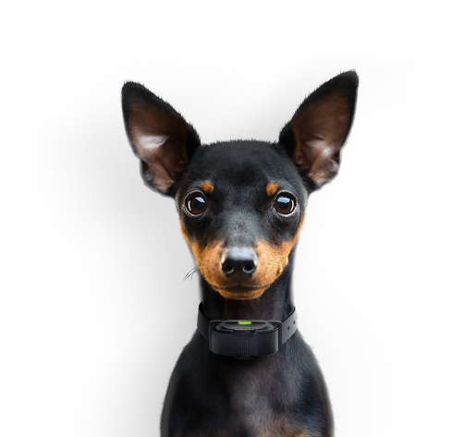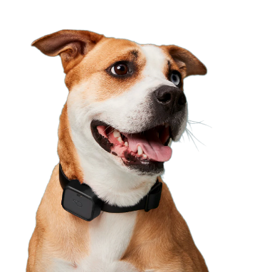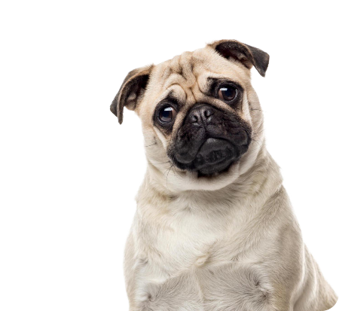

**Results**

|  |  |  |  |  |
| --- | --- | --- | --- | --- |
|  |  |  |  |  |
|  |  |  |  |  |
| Afkrydsning med massiv udfyldning | Tilføj med massiv udfyldning | Afkrydsning med massiv udfyldning | Tilføj med massiv udfyldning | Afkrydsning med massiv udfyldning |
|  |  |  |  |  |

**Materials**

The dataset selected contains a collection of over 12,000 images of dogs, covering a diverse range of breeds, sizes, and poses. Additionally, it includes an equivalent number of images featuring objects, landscapes, people, and other animals, collectively referred to as non-dogs.

**Introduction**

Our project focuses on optimizing lost pet recovery, by developing a powerful dog classifier using convolutional neural networks. By swiftly identifying dogs in images, we're enhancing the chances of quick reunions with their owners.

**Conclusion**

Our training has demonstrated promising results. There is a consistent downward trend in training loss, as well as a steadingly increasing training accuracy, indicating that our model is effectively learning to distinguish between dogs and non-dogs in the images. Running additional epochs beyond the initial 150 may yield even more refined results, further enhancing the model's performance and its potential impact on optimizing lost pet recovery efforts.

**TO DOG OR NOT TO DOG**

Marius Skjold Bjerg, Victoria Raunholt Egholm, Lasse Jensen, Thomas Kaae - SW6

Loss 0,12  
Accuracy 0,97  
Epochs 150  
32x32x3